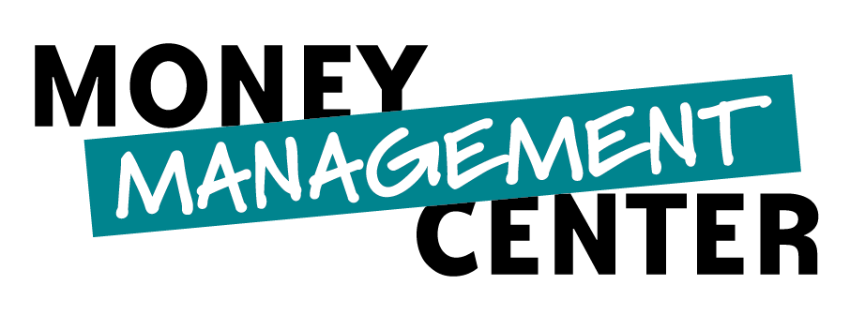 FINANCIAL WELLNESS ASSESSMENT
1. What percentage of your income have you saved during the last six months? A.10 percent or more B. Less than 10 percent C. None
2. How many times during the last six months has one of your credit cards or store cards reached its maximum limit?
A. None B. One to two C. Three or more
3. How many times during the last six months has one of your bank accounts been overdrawn? A. None B. One to two C. Three or more
4. How many times during the last six months has a bill been paid late? A. None B. One to five C. Six or more
5. How many credit cards and/or store cards do you have for personal use? A. Three or fewer B. Four to six C. Seven or more
6. If you lost your source of income, how many months could you provide for all of your basic needs and meet each of your financial obligations?
A. Three or more B. One to three C. Less than one
7. When a credit card or store card is used to make a purchase, how often is the entire balance paid the following month?
A. Always B. Sometimes C. Never
8. If a major appliance purchase or repair, auto repair or home repair were suddenly required, what source of money would be used to pay for it?
A. Funds already on-hand B. Funds from available credit C. No funds would be available without establishing additional credit
9. If you are single, how frequently during the last six months have you spent time reviewing your financial situation and making financial decisions? If you have a partner, how frequently during the last six months have you spent time with your partner reviewing your joint financial situation and making joint financial decisions?
A. Weekly B. Monthly C. Rarely, to not at all
10. How many times during the last year have you spent time with your partner reviewing your retirement plan? If you are single, how many times have you spent time reviewing your own retirement plan?
A. One or more B. None C. Don’t have a retirement plan
11. Have you created a written budget during the last 12 months?
A. Yes B. I have a budget but it is not written out. C. What budget? I once rented a car from Budget; does that count?
12. How often is a monthly budget used to manage household spending?
A. Almost always B. Sometimes C. Rarely to never
13. What information do you use most often to determine if regular household purchases can be made?
A. The balance remaining in the budget. B. The balance remaining in a bank account, credit card or store card. C. Little to no information—spending is so much easier when I don’t think about it!
14. The insurance I have to cover the loss of major assets, including real estate, autos and personal property is:
A. Enough to cover the replacement cost. B. Less than enough to cover the replacement cost. C. An amount I’m unsure about, or I don’t have coverage.
15. The insurance I have to cover the loss of life is:
A. Enough to cover interment costs and adequately replace my income for remaining dependents. B. Enough to cover interment costs but not enough to adequately replace my income for remaining dependents. C. An amount I’m unsure of, or I don’t have coverage.
16. The insurance I have to cover a disability is:
A. Enough to adequately replace my current income. B. Less than enough to adequately replace my current income. C. An amount I’m unsure of, or I don’t have coverage.
17. The last time a major purchase was made, the primary consideration was: A. The total purchase price relative to available funds. B. The monthly payment relative to available monthly cash flow. C. The monthly payment without a complete understanding of its impact.
18. Most major purchases are: A. Planned and saved for B. Planned but not adequately saved for C. Unplanned and spontaneous—hey, they’re having free hotdogs at the local furniture store; let’s go check out the deals on big-screen TV’s.
19. How often do you check to make sure you have adequate funds in your bank account(s)?
A. They usually don’t need to be checked because I always have adequate funds B. Weekly C. Almost daily
20. How often are issues related to finances the root of conflict in your household?
A. Rarely if ever B. A few times each month C. Frequently—we just installed a boxing ring in the family room right in front of the new big-screen TV!
21. How is your overall financial situation this year compared with last year at this time?
A. Better B. About the same C. Worse
22. When I think about my ability to meet future financial obligations for major items (like education or major purchases, etc.), I am:
A. Completely at ease B. Moderately concerned C. Very much concerned
23. When I think about my ability to meet future financial obligations and maintain an acceptable lifestyle at retirement, I am:
A. Completely at ease B. Moderately concerned C. Very much concerned

Scoring: Count the number of A, B and C answers and return to the Money Management Center table to discover your level of financial wellness.
A. _______ X 1 = _______ B. _______ X 3 = _______ C. _______ X 5 = _______ TOTAL = _______

